From
“A Summary of the Christian Faith”
by David Chytraeus (1568)

On Eternal Life

“God so loved the world that He gave His only begotten Son that whosoever believes in Him may not perish, but have everlasting life,” John 3. “This is the will of God, that everyone who sees the Son and believes in Him not perish, but have eternal life,” John 6. “This is eternal life, that we know You, the only true God, and Jesus Christ, whom You have sent,” John 17.

What is eternal life?

Eternal life will be the presence of God by which the Church is raised from the dead and is completely freed from every sin. It will see face to face the essence and will of the entire Godhead, of the eternal Father, Son, and Holy Spirit. God will fill it with new and eternal light, wisdom, righteousness, eternal life and joy, and the Church in turn will praise God.

To God be the Glory!
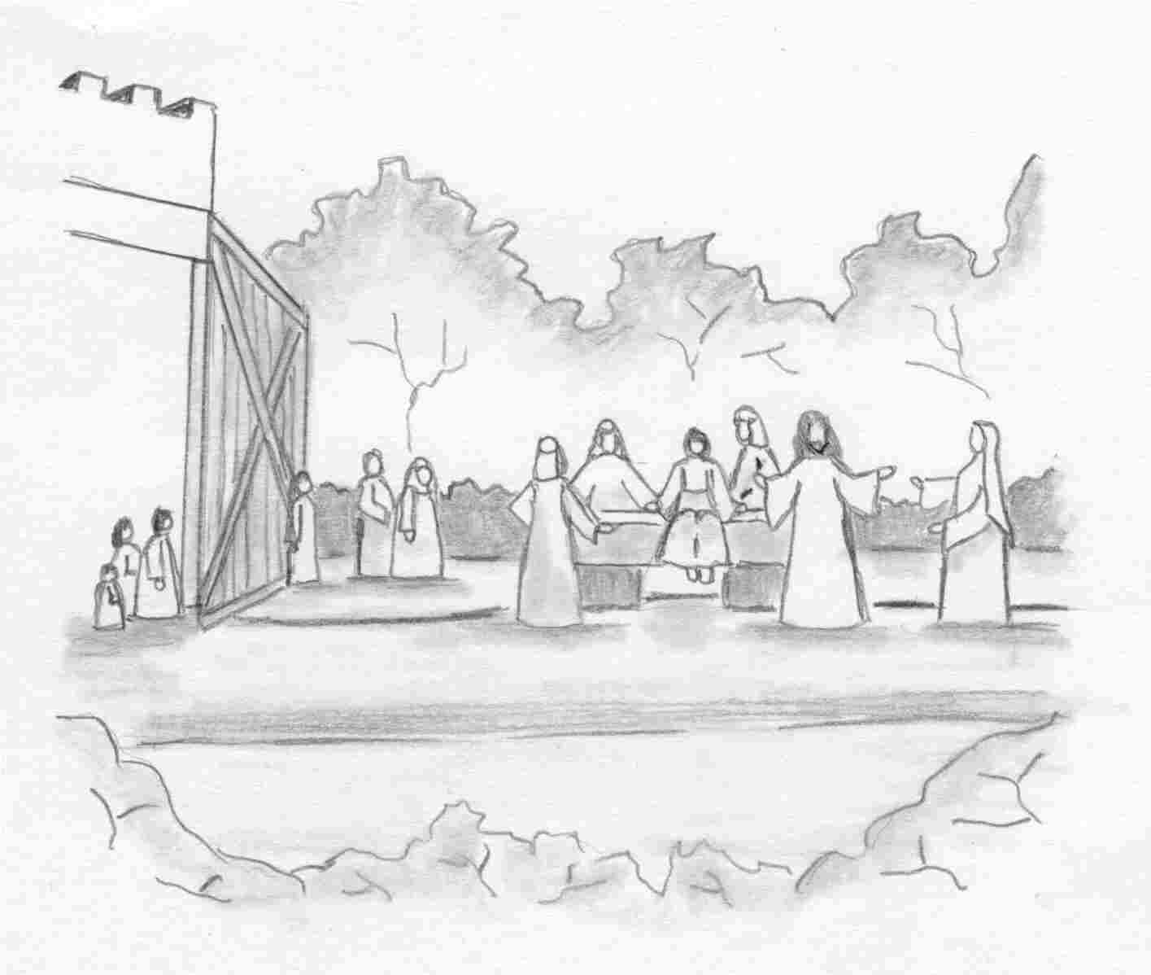
And He presented him to his mother.

Our Redeemer Lutheran Church
403 South Hayes
Emmett, Idaho 83617 Church: 208-365-5231

Pastor: Rev. Michael L. McCoy
parsonage: 208-365-5214
email: mmccoy19@earthlink.net
www.scholia.net – the website for:
Good News for the Diaspora!
scholia.net publishing – Where the Word is not Bound
Predici in limba romana – (Sermons in Romanian)
The artwork is by Sharon Geiser. Permission to use this copyrighted graphic is limited to congregational use. The quotation above is by David Chytraeus and is from his 1568 work A Summary of the Christian Faith. The English translation is by Rev. Dr. Richard Dinda and is published by Repristination Press. For information on this book and other books by Repristination Press see the website below.

This bulletin cover provided by www.scholia.net and is made available without cost.

20 June Anno Domini 2004

Trinity 2 / Pentecost 3
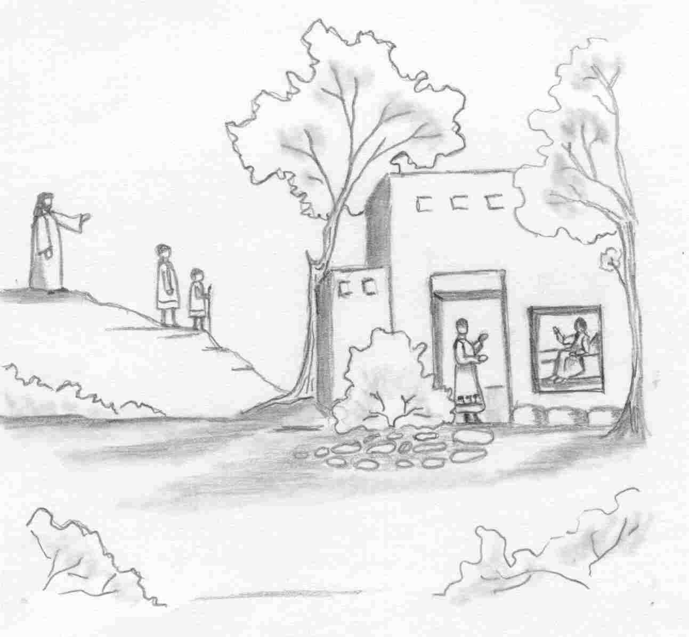
But say the Word,
and my servant will be healed.

To place the graphic on this page:
Copy the graphic on the previous page.
Click on the open space above and a graphic box should appear. Paste the graphic.

Change this frame and the box above by clicking the body of the text and adding the particulars. (See the previous page for an example.)
The artwork is by Sharon Geiser. Permission to use this copyrighted graphic is limited to congregational use. The quotation above is by David Chytraeus and is from his 1568 work A Summary of the Christian Faith. The English translation is by Rev. Dr. Richard Dinda and is published by Repristination Press. For information on this book and other books by Repristination Press see the website below.

This bulletin cover provided by www.scholia.net and is made available without cost.

20 June Anno Domini 2004
Trinity 2 / Pentecost 3
And He presented him to his mother.

From
“A Summary of the Christian Faith”
by David Chytraeus (1568)

On Eternal Life

“God so loved the world that He gave His only begotten Son that whosoever believes in Him may not perish, but have everlasting life,” John 3. “This is the will of God, that everyone who sees the Son and believes in Him not perish, but have eternal life,” John 6. “This is eternal life, that we know You, the only true God, and Jesus Christ, whom You have sent,” John 17.

What is eternal life?

Eternal life will be the presence of God by which the Church is raised from the dead and is completely freed from every sin. It will see face to face the essence and will of the entire Godhead, of the eternal Father, Son, and Holy Spirit. God will fill it with new and eternal light, wisdom, righteousness, eternal life and joy, and the Church in turn will praise God.

To God be the Glory!

